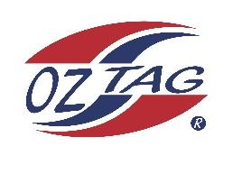

2023 Sutherland Shire Stingrays
Under Girls 14 Representative

Congratulations to the following players selected in the Under14 Team to represent Sutherland Shire Stingrays.

 | Name
1 | Kalani Anderson
2 | Aneska Barling
3 | Eva Benton
4 | Sienna Best
5 | Ocean Bradley
6 | Brooke Carroll
7 | Noa Coupland
8 | Paige Debreczini
9 | Ava Dwyer
10 | Dolly Fava
11 | Haylee Hanley
12 | Lyla Hawksworth
13 | Rhianna Karika
14 | Ashleigh L’Estrange
15 | Monique Marshall
16 | Tahli Weigand
 | SHADOWS (In no particular order)
17 | Emeline Bourke
18 | Amalee Doyle
19 | Emily Rebeiro
20

Division: U14 Girls
Coaches: Brett Carroll / Derryn Weigand / Mat Karika
Phone: 0416248125
Email: bacarroll@live.com.au

Manager:
Phone:
Email:

