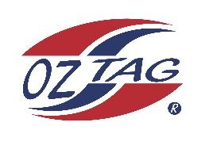

2023 Sutherland Shire Stingrays
Under Girls 9 Representative

Congratulations to the following players selected in the under 9 team to represent Sutherland Shire Stingrays.

 | Name
1 | Annabelle Sharratt
2 | Ava Gardiner
3 | Evelyn Ennis
4 | Halle Byrne
5 | Harper Cavdarovski
6 | Harper Haydon
7 | Izzy Swanton
8 | Karia Kingi
9 | Lila Mott
10 | Lilly Evans
11 | Luca Ross
12 | Lucy Devine
13 | Mia Brown
14 | Pollyanna Lemke
15 | Stevie Caine
16 | Tiana Wilkinson
17 | Indi Smoothey-Miller
18 | Jerrico Hayllar
19 | Lilly Mae Robinson
20 | Maddison Lakomy

Division: U/9 Girls
Coach/s: Brendan Mott
Phone: 0413211393
Email: brendan.mott@hotmail.com

Manager: TBC
Phone:
Email:

