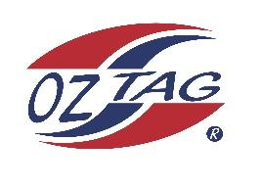

2023 Sutherland Shire Stingrays
Under Boys 15 Representative

Congratulations to the following players selected in the under U15 Boys team to represent Sutherland Shire Stingrays.

 | Name
1 | Toby Beckette
2 | Hamish Barlow
3 | Cooper Bowden
4 | Hayden Clarke
5 | Locky Gallagher
6 | James Hodge
7 | Luke Jenkins
8 | Brodie Johnsen
9 | Martin Lim
10 | River McMahon
11 | Tom Powell
12 | Cooper Starr
13 | Spencer Swann
14 | William Watson
15 | Zack Woodger
16 | Hugh Windon
17 | Harley Brown
18 | Daniel Green
19 | Billy Rose
20

Division: U15 Boys
Coach/s: Jared Starr / Tim Jenkins
Phone: 0421 079 159
Email:

Manager: Dom Barlow
Phone:
Email:

