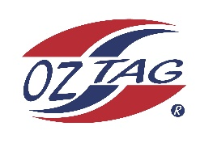
2023 Sutherland Shire Stingrays
Under 13 Girls Representative
Australian National Championships Cup Coffs Harbour

Congratulations to the following players selected in the under 13 Girls team to represent Sutherland Shire Stingrays.

1 | Eden Edwards
2 | Ivy Kimmorley
3 | Siannah Carangelo
4 | Taylor Proudlock
5 | Kalea Lloyd
6 | Shaleah Field
7 | Sienna Bedwell
8 | Keziah Behringer
9 | Jenna Boyce
10 | Ivy Davidson
11 | Jarra Tinker
12 | Lily Tickle
13 | Miri Hughes
14 | Emma Payne
15 | Tanaya Waiwai
16 | Jazmine Jackson
 | Shadows (in no particular order)
17 | Cyrus Mikora
18 | Sarah Lagerlow
19 | Skyla Sleeman
20 | Zara Zammit

Division: 13 Girls

Coach/s: Ben Tickle
Phone: 0410454667
Email: ben.tickle@syd.catholic.edu.au

Manager: Amanda Tickle
Phone: 0403280163
Email: atickle09@hotmail.com

