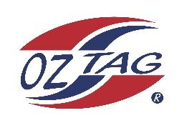

2023 Sutherland Shire Stingrays
Under Girls 11 Representative

Congratulations to the following players selected in the under 11 team to represent Sutherland Shire Stingrays.

 | Name
1 | Havana Anderson
2 | Giselle Barlow
3 | Sage Boothroyd
4 | Halle Bostick
5 | Mackenzie Brown
6 | Miami Cooper
7 | Chloe Galloway
8 | Ashlyn Gorman
9 | Chelsea Grushot
10 | Aaliyah Hawkins
11 | Jordyn Helm
12 | Malia Longbottom
13 | Imogen Marinos
14 | Chloe McKevett
15 | Isla Redman
16 | Tilly Swanton
17 | Isla Vilivilli
18 | Chiara Bradley
19 | Leilani Rathgen
20 | Molly Murr
21 | Tenaya Tanner

Coach: Amy Helm
Phone: 0403 377 436

Trainer: Adrian McKevett
Trainer: Sienna Davey

