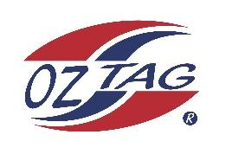

2023 Sutherland Shire Stingrays
Under Boys 11 Representative

Congratulations to the following players selected in the under 11 Boys team to represent Sutherland Shire Stingrays.

 | Name
1 | Jamie Nisbet
2 | Boston Martin
3 | Knox Anderson
4 | Taio Dorahy
5 | Sonny Gilder
6 | Nolan Grantham
7 | Jackson Best
8 | Noah Kelly
9 | Ethan Coupe
10 | Travis Carter
11 | Billy Herb
12 | Arlo McPherson
13 | Zach Wilson
14 | Taj Morris
15 | Roman Vula
16 | Alexander Sheppard
17 | Braxton Horsey
18 | Caleb Hoekstra
19 | Benjamin Rebeiro
20 | Jaxon Magee

Division:
Coach/s: Adam McPherson & Brad Gilder
Phone: 0432 673 738 – 0476 777 666
Email: secretary@tarenpointtitans.com - brad@gilders.com.au

Manager: Brigitte Salib
Phone: 0478 192 119
Email: brigittesalib@hotmail.com

