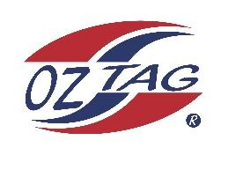

2023 Sutherland Shire Stingrays
Under 16 Boys Representative

Congratulations to the following players selected in the under 17 Boys team to represent Sutherland Shire Stingrays.

 | Name
1 | Jett Murphy
2 | Harrison Cavanagh
3 | Dylan Pisani
4 | Zane Pisani
5 | Jackson Turner
6 | Tate Nichols
7 | Luca Pirrello
8 | Jarvis Wever
9 | Logan Buddle
10 | Liam Bova
11 | Koby Wallace
12 | Jake Tomkins
13 | Joel Cornock
14 | Isacc Lopes
15 | Axel Murphy
16
17
18
19
20

Division: Boys 16’s
Coach/s: Lee Murphy
Phone: 0406 694 765
Email:

Manager:
Phone:
Email:

