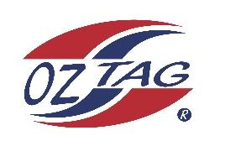

2023 Sutherland Shire Stingrays
Under 10 Boys Representatives

Congratulations to the following players selected in the under 10 Boys team to represent Sutherland Shire Stingrays.

 | Name
1 | Oliver AITKEN
2 | Luka ARBINJA
3 | Nate BROWN
4 | Lachie BUTLER
5 | Jett CARROLL
6 | Nash CAVANAGH
7 | Ryan COHEN
8 | Zane FERGUSON
9 | Joey GUMLEY
10 | Beau HEWITT
11 | Leon HINTON
12 | Arky MONAGHAN
13 | Grayson ROPER
14 | Oscar SCHREIBER
15 | Axel SLATER
16 | Oliver THOMAS-BENNIE
 | SHADOWS (NO PARTICULAR ORDER)
17 | Aiden HAWES
18 | Carter BYRNE
19 | Hunter BRENTON
20 | Ziggy TAUTAI

Division: Boys Under 10’s
Coach/s: Steve Monaghan & Dean Slater
Phone: 0423 126 754
Email: stevo184@hotmail.com

Manager: Gretchen Slater
Phone: 0430 309 330
Email: gretchren@gmail.com

