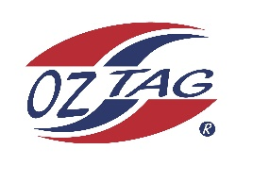

2023 Sutherland
Under 16 Girls Representative

Congratulations to the following players selected in the under 16 squad to represent Sutherland.

1 | Alexi Eizenberg
2 | Brooklyn Kingi
3 | Chloe Liddell
4 | Charlee Hedley
5 | Candice Laffan
6 | Ella Hewitt
7 | Emma Gorman
8 | Gemma Hanley
9 | Georgie Lauxmann
10 | Hannah Barlow
11 | Keira Lapasona
12 | Leah Moffitt
13 | Lily Chapple
14 | Madison Marshall
15 | Sophia Rose
16 | Tully Rayner
 | Shadows (in no particular order)
17 | Tace Edwards
18 | Isabella Quilkey
19 | Chloe Mears
20

Division: 16 Girls

Coach Leanne Laffan
Phone: 0409922773

Manager: Louise Liddell
Phone: 0417020185

