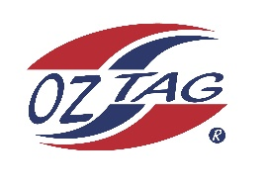

2023 Sutherland
Under 13 Girls Representative

Congratulations to the following players selected in the under __13______ squad to represent Sutherland.

1 | Taylor Gorman
2 | Lucia Schob
3 | Akira Rikihana
4 | Imogen Keep
5 | Ivy Davidson
6 | Zara Wadland
7 | Shaleah Field
8 | Taylor Shaw
9 | Mia Barbuto
10 | Ngamiri Hughes
11 | Taylor Proudlock
12 | Kalea Lloyd
13 | Charlie Eason
14 | Evelyn Devaney
15 | Cyrus Nikora
16 | Matilda Humphrey
 | Shadows (in no particular order)
17 | Sophie Tucker
18
19
20

Division: 13 girls

Coach/s: Chad Barbuto & Jason Hughes
Phone:0408632286
Email: chad@blownawayelectrical.com.au

Manager: Brianne Gorman
Phone:0430407095
Email: brianne@greenview.net.au

