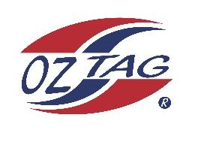

2023 Sutherland
Under 12 Girls Representative Squad

Congratulations to the following players selected in the under 12 squad to represent Sutherland. Players will attend a compulsory training sessions on Friday (24/11/2022), before the team is finalised. The squad will then be finalised as 16 players and 4 shadows.

 | Name
1 | Joscyln Lemke
2 | Ruby Walker
3 | Leah Fowler
4 | Capri McCarthy
5 | Jael McGregor
6 | Lucy Watkins
7 | Ella Beckett
8 | Taylah Hunt
9 | Beau Green
10 | Riley Smith
11 | Zara Wood
12 | Halle Ferguson
13 | Georgia Laverence
14 | Mikayla Khan
15 | Pippa Dowsett
16 | Lylah Henderson
17 | Michaela Jenkins
18 | Piper Brenton
19 | Ava Garvan
20 | Ella Gardiner

Division: Under 12s Girls

Coach/s: Britney Vella and Michael McCarthy
Phone: 0435113045
Email: Britney.vella1@gmail.com

Manager: N/A
Phone: N/A
Email: N/A

