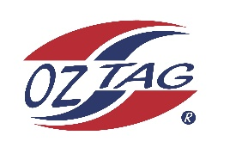

2023 Sutherland
Under 14 Boy Representative

Congratulations to the following players selected in the under 14’s
squad to represent Sutherland.

1 | Jake Gallard
2 | Tyler Doonan
3 | Zaiden Green
4 | Mannix Tuazon
5 | Blake Rapson
6 | Ashton Astudillo
7 | Jaxon Gotch
8 | Jai Brown
9 | Zach O’Hanlon
10 | Rhys Phillips
11 | Kade Wilson
12 | Mason Stewart
13 | Lucas Gamble
14 | Cooper Compton Perry
15 | Harper Boothroyd
16 | Robbie Skelcher
17 | Kai Watson
18 | Cruz Brown
19
20
Division: Boys U/14’s

Coach/s: Justin Brown / PJ Tuazon
Phone: 0417 408742 / 0422 977852
Email: jbrwn025@gmail.com / pjtuazon1@hotmail.com

Manager: Andy Phillips
Phone:
Email:

