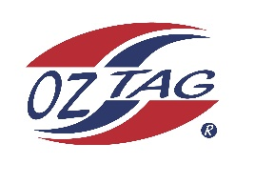

2023 Engadine/Heathcote
Under 12S Girls Representative

Congratulations to the following players selected in the under 12s Girls squad to represent Heathcote/Engadine.

1 | Indiana Yusuf
2 | Willow Dowling
3 | Ayrleigh Gibbons
4 | Winnie Ryan
5 | Matilda Luck
6 | Ivy Brander
7 | Darcy Pickering
8 | Jackie Ives
9 | Mia Croucher
10 | Mikayla Cox
11 | Chloe Macken
12 | Sailor Gurney
13 | Summer Stewart
14 | Asher Love
15 | Layla Harman
16 | Chloe Varney
 | Shadows (in no particular order)
17
18
19
20

COACH: Tanya Gibbons – 0403 691 003
MANAGERS: Sarah Gurney - 0419 258 117
Jackie Wood – 0457 187 881

