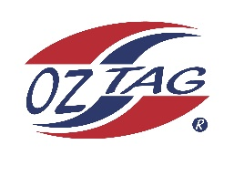

2023 Engadine/Heathcote
Under 9s Boys Representative

Congratulations to the following players selected in the under 9s Boys squad to represent Heathcote/Engadine.

1 | Hugh McBride
2 | Alexander Reid
3 | Slater Gibbons
4 | Oliver Tanner
5 | Storm Simonsen
6 | Tyler Mingare
7 | Ryan Jones
8 | Dash Bostick
9 | Channing Taylor
10 | Max Morton
11 | Charlie Jacotine
12 | Cruz Laws
13 | Kaiden Stevens
14 | Jack Collins McCoubrey
15 | ArcherGarvan
16 | Oliver Garvan
 | Shadows (in no particular order)
17 | Magnus Ryan
18 | Jayden Shipway
19 | Gordon Ives
20 | Caden Jenkins

21 Lucas O’Reilly
22 Hayden Whitney
COACH: Gina Bostick – 0418 450 952
Email: gg.bostick@bigpond.com
COACH: Kristie Morton – 0439 700 818

