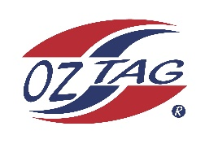

2023 Engadine/Heathcote
Under 13 Boys Representative

Congratulations to the following players selected in the under 13 Boys squad to represent Heathcote/Engadine.

1 | Fletcher Ablett
2 | Coby Anttilla
3 | Ethan Coleman
4 | Levi Dawson
5 | Jack Gurney
6 | Corey Hayward
7 | Ryder Lupton
8 | Dane McKeon
9 | Chase Nisbet
10 | Bailen Oates
11 | Cash Peek
12 | Zac Porter
13 | Brodie Routh
14 | Zeplin Sauvan
15 | Phoenix Smith
16 | Deakin Struthers
 | Shadows (in no particular order)
17 | Mitch Bowling
18 | Taj Liddy
19 | Dylan Sammut
20 | Cooper Wisdom

COACH: Adam Peek – 0416 342 647
MANAGER: Brad Routh – 0409 201 180

