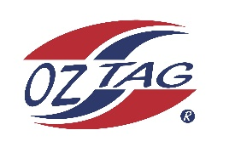

2023 Cronulla
Under 17 Girls Representative

Congratulations to the following players selected in the under 17 team to represent Cronulla.

 | Name
1 | Marnie Isemonge
2 | Rylee Hulbert
3 | Chloe Benton
4 | Lilly Henderson
5 | Scarlett Salib
6 | Sienna Davey
7 | Tegan Jenkins
8 | Ava Kimmorley
9 | Elyssa Redrup
10 | Eliza Feros
11 | Sienna Grek
12 | Kobe Maher
13
14
15
16
 | Shadows (in no particular order)
17
18
19
20

Division: Girls 17

Coach/s: Angela & Matt Davey
Phone: 0404494440
Email: angdavey72@gmail.com

Manager: Leah Salib
Phone: 0400 101 214
Email:

