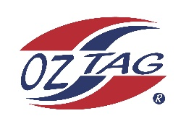

2023 Cronulla
Under 14 Boys Representative

Congratulations to the following players selected in the under 14 Boys squad to represent Cronulla.

1 | Axel Murphy
2 | Ashton Carroll
3 | Benji Halloran
4 | Brodie Dorahy
5 | Charlie Rapp
6 | Curren Tapper
7 | Hamilton Kingi
8 | Jahree Katene
9 | Jayden Best
10 | Kayden Anthony
11 | Marshall Anderson
12 | Noah Kennedy
13 | Tyler Bowran
14 | Zac Redman
15 | Ziggy Hughes
16 | Xavier Young
 | Shadows (in no particular order)
17 | Kobe Cook
18 | Kaike McKinley
19 | Cooper Compton Perry
20 | Archer Sorenson

Division: Cronulla 14 Boys

Coach/s: Luke Wever/Jason Dorahy
Phone:0400 421 657 / 0414 272 681
Email: weverluke@gmail.com / Jason.dorahy@gmail.com

Manager: Luke Wever
Phone:0400421657
Email: weverluke@gmail.com

