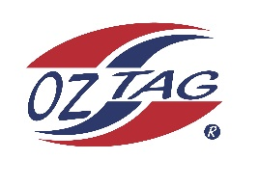

2023 Cronulla
Under 13 Boys Representative

Congratulations to the following players selected in the under 13 squad to represent Cronulla

1 | Austin Highett
2 | Bailey Silver
3 | Ben Croser
4 | Bear Laffan
5 | Cruz Wever
6 | Cooper Rye
7 | Ethan Mullins
8 | Jack Mckevett
9 | Kash Lemke
10 | Koa Cooper
11 | Lachie Mooney
12 | Lenny Bucher
13 | Marshall Barlow
14 | Roy Eisenhuth
15 | Randy Ennis
16 | Zane Smith
 | Shadows (in no particular order)
17 | Cooper Brenton
18 | Tyler Hastie
19 | Harry Fisher
20  21 | Jaxon Redmayne  Vincent Pirrello

Division: 16 Girls

Coach Paul Laffan
Phone: 0419288851

Manager: Leanne Laffan
Phone: 0409922773
Text Leanne to accept your spot

