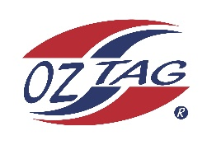

2023 Cronulla
Under 12 Boys/Girls Representative

Congratulations to the following players selected in the under 12 boys to represent Cronulla.

1 | Lochie Schumacher
2 | Zuma Wever
3 | Tyson Sedhom
4 | Brax Lemke
5 | Hunter Aston
6 | Kai Wheatstone
7 | Jackson Smith
8 | Pax Caine
9 | Manny Hinton
10 | Jaxon Sorensen
11 | Harley Gardner
12 | Kody Gallen
13 | Jaxen Tickle
14 | Jaxon Brown
15 | Phoenix Black
16 | Beau McDonald

Division: Boys 12’s

Coach/s: Tony Schumacher Sedhom
Phone: 0424311358

Manager: Kristy Schumacher
Phone: 0409524360
Email: Kristy_schuey@hotmail.com

