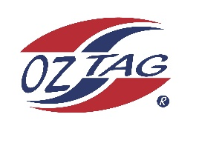
2022 Sutherland Shire Stingrays
Under Boys/Girls Representative squad
Australian National Championships Cup Coffs Harbour

Congratulations to the following players selected in the under U14 Boys squad to represent Sutherland Shire Stingrays.

1 | Tom Powell
2 | Brodie Johnson
3 | Zack Woodger
4 | Cooper Bowden
5 | Cooper Starr
6 | Hayden Clark
7 | Luke Jenkins
8 | Hugh Windon
9 | Hamish Barlow
10 | Riley Smith
11 | River McMahon
12 | Locky Gallagher
13 | Martin Lim
14 | Harley Brown
15 | Tobi Beckett
16 | Henry Luthje
 | Shadows (in no particular order)
17 | Jet Jones
18 | James Hodge
19
20

Division: U14 Boys

Coach/s: Jared Starr / Tim Jenkins
Phone: 0421 079 159
Email:

Manager: TBA
Phone:
Email:

