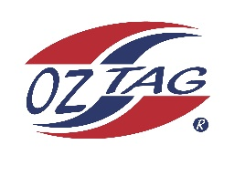
2022 Sutherland Shire Stingrays
Under 12 Girls Representative squad
Australian National Championships Cup Coffs Harbour

Congratulations to the following players selected in the under 12 Girls squad to represent Sutherland Shire Stingrays.

1 | Eden Edwards
2 | Ivy Kimmorley
3 | Siannah Carangelo
4 | Ava Hawes
5 | Allegra Little
6 | Shaleah Field
7 | Sienna Bedwell
8 | Keziah Behringer
9 | Jenna Boyce
10 | Tayha Owsnett
11 | Jarra Tinker
12 | Lily Tickle
13 | Tamarli Haydon
14 | Emma Payne
15 | Tanaya Waiwai
16 | Jazmine Jackson
 | Shadows (in no particular order)
17 | Holly Sims
18 | Sarah Lagerlow
19 | Skyla Sleeman
20 | Zhra Tautai

Division: 12 Girls

Coach/s: Ben Tickle
Phone: 0410454667
Email: ben.tickle@syd.catholic.edu.au

Manager: Amanda Tickle
Phone: 0403280163
Email: atickle09@hotmail.com

