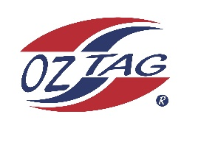
2022 Sutherland Shire Stingrays
Under Boys/Girls Representative squad
Australian National Championships Cup Coffs Harbour

Congratulations to the following players selected in the under 12 BOYS squad to represent Sutherland Shire Stingrays.

 | NAME
1 | BEAR LAFFAN
2 | BAILEY SILVER
3 | BAILEN OATES
4 | CRUZ WEVER
5 | COREY BROWN
6 | COOPER BRENTON
7 | CRUZ MORRIS
8 | JACK MCKEVETT
19 | KASH LEMKE
10 | KIAN DOGGER
11 | LENNY BUCHER
12 | LACHIE MOONEY
13 | MARSHALL BARLOW
14 | ROY EISENHUTH
15 | TYLER HASTIE
16 | ZANE SMITH
 | Shadows (in no particular order)
17 | JACK GURNEY
18 | JACOB MAY
19 | BRONSON STEWART

Division:
12 BOYS
Coach/s: PAUL LAFFAN
Phone: 0419288851
Email:

Manager: LEANNE LAFFAN
Phone: 0409922773 TEXT LEANNE TO CONFIRM YOUR SPOT PLS
Email:

