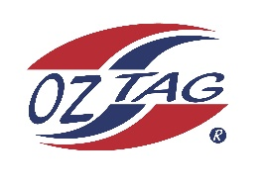
2022 Sutherland Shire Stingrays
Under 10 Boys Representative squad
Australian National Championships Cup
Coffs Harbour

Congratulations to the following players selected in the under 10 boys squad to represent Sutherland Shire Stingrays.

1 | Knox Anderson
2 | Ethan Coupe
3 | Taio Dorahy
4 | Taj Forster
5 | Sonny Gilder
6 | Koby Hyde
7 | Boston Martin
8 | Jaxon Magee
9 | Arlo McPherson
10 | Taj Morris
11 | Braxton Monaghan
12 | Jamie Nisbet
13 | Benjamin Rebeiro
14 | Chase Spradbrow
15 | Alex Sheppard
16 | Harlem Tuazon
 | Shadows (in no particular order)
17 | Finn Murrell
18 | Hayden Croft
19 | Jacob Needham
20 | Zac Maguire

Division: 10 Boys

Coach/s: Adam McPherson, Brad Gilder
Phone: 0432673738, 0476777666
Email: Secretary@tarenpointtitans.com Brad@Gilders.com.au

Manager: Paris Evans
Phone: 0422734978
Email: Paris_evo@hotmail.com

