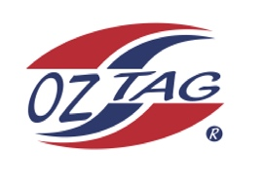
Boys Under 14 Cronulla State Cup Representative Team 2021

Congratulations to the following players selected in the 2022
Sutherland representative team

1. | Brodi Johnsen
2. | Finn Hansell
3. | Tobi Beckett
4. | Hamish Barlow
5. | Novak Tomevski
6. | Zack Woodger
7. | Billy Rose
8. | Zach Molloy
9. | Kody Moon
10. | Ryan Riley
11. | Dylan Stark
12. | Ethan Murr
13. | Ashton Cotton
14. | Tighe Devane
15. | Naite Garne
16.
 | SHADOWS (IN NO PARTICULAR ORDER)
1.
2.
3.
4.

Coaches Dave and Gab Rose
Coach. ____________________________ Mobile. ____________________

Email ________________________________________________________

Manager. __________________________ Mobile_______________________

Email ________________________________________________________

Email ____________________________________________________________

