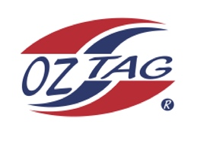
Boys Under 11Cronulla State Cup Representative Team 2021

Congratulations to the following players selected in the 2022
Sutherland representative team

1. | Tyson Sedham
2. | Jaxen Tickle
3. | Brax Lemke
4. | Kai Wheatstone
5. | Zuma Wever
6. | Lochie Schumacher
7. | Jaxon Sorensen
8. | Hunter Stanley
9. | Manny Hinton
10. | Hunter Aston
11. | Jar;eu Gardmer
12. | Darcy Wilson
13. | Lorenzo Babruto
14. | Issac Bevan
15.
16.
 | SHADOWS (IN NO PARTICULAR ORDER)
1.
2.
3.
4.

To accept your position please text/email the coach
By Friday 25th February 2022

Coach. ____________________________ Mobile. ____________________

Email ________________________________________________________

Manager. __________________________ Mobile_______________________

Email ________________________________________________________

Email ____________________________________________________________

