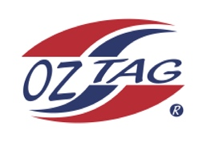
Girls Under 9 Sutherland State Cup Representative Team 2021

Congratulations to the following players selected in the 2022
Sutherland representative team

1. | Havana Palister
2. | Scarlett Tracy
3. | Clea Eldson
4. | Koa Barbuto
5. | Eva Anasis
6. | Zahli Bates
7. | Chelsea Ewings
8. | Chloe Lucas
9. | Daisy Lopez
10. | Miley Ryan
11. | Jade Barlow
12. | Indra Stevens
13. | Ella Sweeney
14. | Neha Sakaria
15. | Taliyah Helps
16.
 | SHADOWS (IN NO PARTICULAR ORDER)
1. | Wynter Bradshaw
2. | Lily Mcauslan
3.
4.

To accept your position please text/email the coach
By Friday 25th February 2022

Coach. ___Kelly Barbuto_____________ Mobile. _____0404354579______

Email ___kelflemo@hotmail.com___________________________________

Manager. _____TBC_________________ Mobile_______________________

Email ________________________________________________________

Email ____________________________________________________________

