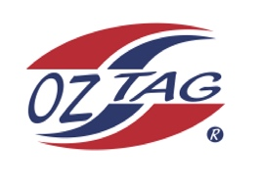
Girls Under 15 Sutherland State Cup Representative Team 2022

Congratulations to the following players selected in the 2022
Sutherland representative team

1. | Alexi Eisenberg
2. | Brooklyn Kingi
3. | Candice Laffan
4. | Chloe Liddell
5. | Charlene Hedley
6. | Emma Gorman
7. | Georgie Lauxmann
8. | Gemma Hanley
9. | Leah Moffitt
10. | Lili Zmisa
11. | Maddie Marshall
12. | Milla Coles
13. | Sophia Rose
14. | Tully Rayner
15. | Tace Edwards
16. | Zoe Gilberd
 | SHADOWS (IN NO PARTICULAR ORDER)
1. | Keira Lampasona
2. | Hayley Walsh
3. | Hannah Barlow
4. | Chloe Mears

To accept your position please text/email the coach
By Friday 25th February 2022

Coach. Leanne Laffan_________________ Mobile.0409922773

Email _

Manager. Louise Liddell____ Mobile 0417020185_______________________

Email ________________________________________________________

Email ____________________________________________________________

