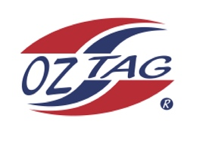
Girls Under 14 Sutherland State Cup Representative Team 2022

Congratulations to the following players selected in the 2022
Sutherland representative team

1. | Nova Batman
2. | Jaeva Bentley
3. | Grace Cramsie
4. | Martha Gregory
5. | Paige Hagan
6. | Ruby Hedley
7. | Sarah Hickey
8. | Riley Hodge
9. | Abbie Jackson
10. | Zara Loveday
11. | Chloe Ozolins
12. | Bridget Rommel
13. | Hannah Silver
14. | Tara Skelton
15. | Sienna Wilson
16. | Charlotte Woolnough
 | SHADOWS (IN NO PARTICULAR ORDER)
1. | Holly Farrell
2. | Jade Murphy
3. | Alicia Thorne
4.

To accept your position please text/email the coach
By Friday 25th February 2022

Coach. Shane Hedley Mobile. 0409464220
Email shane@hedleyaccounting.com.au

Manager. Dee Ozolins Mobile. 0434870546
Email deeors@yahoo.com.au

