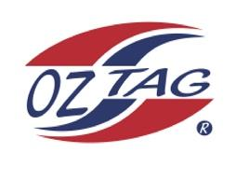
Girls Under 11 Sutherland State
Cup Representative Team 2021

Congratulations to the following players selected in the 2022
Sutherland representative team

1. | Jocelyn Lemke
2. | Halle Fergurson
3. | Ruby Walker
4. | Leah Fowler
5. | Georgia Laverence
6. | Lucy Watkins
7. | Ella Beckett
8. | Taylah Hunt
9. | Grace Stegbauer
10. | Pippa Dowsett
11. | Jael McGregor
12. | Keelie Massone
13. | Charli Harrower
14. | Ella Gardiner
15. | Capri McCarthy
16. | Piper Brenton
 | SHADOWS (IN NO PARTICULAR ORDER)
1. | Mikayla Khan
2. | Andie Hedley
3. | Elisa O’Connell
4. | Talia Panozzo
5. | Gracie Rapp

To accept your position please text/email the coach
By Friday 25th February 2022

Coach: Britney Vella Mobile: 0435 113 045

Email: britney.vella1@gmail.com

Manager: Belinda Laverence Mobile: 0452 301 060

Email: belindalaverance@yahoo.com.au

