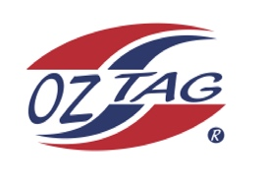
Boys/Girls Under 9’s Sutherland State Cup Representative Team 2021

Congratulations to the following players selected in the 2022
Sutherland representative team

1 | Jack Dooley
2 | Zane Ferguson
3 | Max Geisker
4 | Remy Goodwin
5. | Beau Green
6. | Joseph Gumley
7. | Cruz Hansell
8. | Austin Howard
9. | Orlando Latimore
10. | Thomas Miller
11. | Bodhi Moyle
12 | Bailey Thatcher
13 | Noah Van Dyk
14 | Jamie Vargas
15 | Cooper Walsh
16 | Remy Wells
 | SHADOWS (IN NO PARTICULAR ORDER) – Not required to train
1. | Hunter Brenton
2. | Luca Dinuzzo
3. | Jude McNamara
4. | Connor O’Keefe

To accept your position please text/email the coach
By Friday 25th February 2022

Coach. Jeremy Latimore Mobile. 0422271983

Email. lats1986@gmail.com

Assistant Coaches. Jason Wells 0439981476
Daniel Walsh 0414618951

