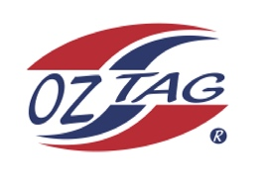
Boys Under 12’s Sutherland State Cup Representative Team 2021

Congratulations to the following players selected in the 2022
Boy’s U12’s Sutherland representative team

1. | Alex Slattery
2. | Cooper Kennedy
3. | Cooper Gentle
4. | Corey Brown
5. | Cruz Morris
6. | Dane Wilson
7. | Finn Crowe
8. | Jax Lees
9. | Jourdan Francois
10. | Kade Edmonds
11. | Kian Dogger
12. | Ollie Hulbert
13. | Owen Fulton
14. | Tommy Ashton
15. | Tommy Lopes
16. | Tyler Hunter
 | SHADOWS (IN NO PARTICULAR ORDER)
1. | Tyler Hastie
2. | Marley Hansell
3. | Sebastian Allen
4. | Issaiaha Murr

To accept your position please text/email the Team Manager
By Monday 28th February 2022

Manager: Michelle Morris Mobile: 0401 326 756

Email: maurelius04@yahoo.com.au

