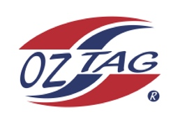
Girls Under 12 Sutherland State Cup Representative Team 2021

Congratulations to the following players selected in the 2022
Sutherland representative team

1. | Ngamiri Hughes
2. | Evelyn Devaney
3. | Emma Payne
4. | Taylor Proudlock
5. | Ivy Davidson
6. | Mia Barbuto
7. | Taylor Shaw
8. | Shaleah Field
9. | Mahli Head
10. | Taylor Gorman
11. | Allegra Little
12. | Zanthie Miller
13. | Lucia Schob
14. | Imogen Keep
15. | Kalea Lloyd
16. | Charlotte Eason
 | SHADOWS (IN NO PARTICULAR ORDER)
1. | Zoe Skelton
2. | Sharne Littman
3. | Ruby Baker
4. | Matilda Humphrey

To accept your position please text/email the coach
By Friday 25th February 2022

Coach. _Chad Barbuto___________ Mobile. 0408632286_____________
Email _chad@blownawayelectrical.com.au

Manager. ___Brianne Gorman____ Mobile__0430 407 095________

Email __briannecooper@hotmail.com_______________

Email ____________________________________________________________

