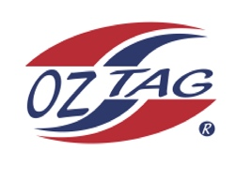
Girls Under 14 Cronulla State Cup Representative Team 2021

Congratulations to the following players selected in the 2022
Cronulla representative team

1. | Keira Aston
2. | Tegan Boyce
3. | Evie Bresnahan
4. | Makayla Brown
5. | Billie Cohen
6. | Kalahni Crews
7. | Kennedee Goodwin
8. | Eyerus Hillman
9. | Millie Hughes
10. | Gabrielle Kent
11. | Stella Milne
12. | Marley Monie
13. | Taryn Mott
14. | Makayla Vakauta
15. | Molly Wepler
16. | Emily Zdjelar
 | SHADOWS (IN NO PARTICULAR ORDER)
1. | Elise Davidson
2. | Imogen Brander
3.
4.

To accept your position please text/email the coach
By Sunday 27th February 2022

Coach. Kieran Bresnahan Mobile. 0410560749

Email Kieranb@mcgrath.com.au

Manager Angela Bresnahan Mobile 0410660749

Email angelabresnahan@mcgrath.com.au

Email ____________________________________________________________

Coach. Kieran Bresnahan Mobile. 0410560749
Email Kieranb@mcgrath.com.au
Manager Angela Bresnahan Mobile 0410660749
Email angelabresnahan@mcgrath.com.au

