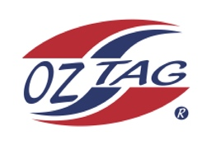
Girls Under 9 Cronulla State Cup Representative Team 2022

Congratulations to the following players selected in the 2022
Sutherland representative team

1. | Abigail O'Flynn
2. | Mayah Tanko
3. | Luara McKinlay
4. | Liberty Athos
5. | Chloe Pun
6. | Jemima Pun
7. | Isla Gladman
8. | Poppy Doyle
9. | Ruby Somerville
10. | Sia Owsnett
11. | Olivia Whitehorn
12. | Victoria Trajcevski
13. | Estelle Raftery
14. | Lily Rikihana
15. | Asha Collins
16. | Riley Bugeja
 | SHADOWS (IN NO PARTICULAR ORDER)
1.
2.
3.
4.

To accept your position please text/email the coach
By Friday 25th February 2022

Coach. _Mat Doyle_____ Mobile. __ 0421084410_____

Email ___ matdoyle1@gmail.com________________________

Manager. _Lauren Gladman___ Mobile___0416194178 __

Email __lauren.gladman.dietitian@gmail.com____________

Email ____________________________________________________________

