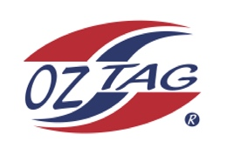
Girls Under13’s Cronulla State Cup Representative Team 2021

Congratulations to the following players selected in the 2022
Cronulla representative team

1. | Kalani Anderson
2. | Eva Benton
3. | Emeline Bourke
4. | Ocean Bradley
5. | Brooke Carroll
6. | Paige Debreczini
7. | Amalee Doyle
8. | Dolly Fava
9. | Haylee Hanley
10. | Lyla Hawksworth
11. | Kalarni Judd
12. | Rhianna Karika
13. | Ashleigh L’Estrange
14. | Monique Marshall
15. | Saige Pritchard
16. | Tahli Weigand
 | SHADOWS
1. | Noa Coupland
2. | Taylor Galloway
3. | Scarlett Hoer
4. | Sienna Best
5. | Kayla Pryde
6 | Emily Brown

To accept your position please text/email the coach
By Friday 25th February 2022

Coach. Kim Carroll Mobile. 0408115350

Email Kim.Carroll3@det.nsw.edu.au
Manager. Sarah Fava Mobile 0417 423 785

Email

Email ____________________________________________________________

