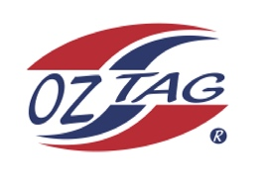

Girls Under 11s Cronulla State Cup Representative Team 2022

Congratulations to the following players selected in the 2022
Cronulla representative team

1. | Indy Oldroyd
2. | Sienna Lakomy
3. | Estelle Slater
4. | Evie Riccio
5. | Maddelyn Cavanough
6. | Elodie Pyne
7. | Imogen D’Apice
8. | Isabella Komon
9. | Madison Palmer
10. | Semara Russell
11. | Allyra Sorensen
12. | Tamika Pike
13. | Olive Maguire
14. | Felicity Barnes
15. | Mackenzie Franks
16. | Lara Flynn
 | SHADOWS (IN NO PARTICULAR ORDER)
1. | Leonie Sarkis
2. | Abby Maddern
3. | Koda Boyle
4. | Piper Wellington

To accept your position please text the coach
By Sunday 27th February 2022
Coach. Jason Russell_________________ Mobile. 0416934472____________________

Email ________________________________________________________

Manager. Louise Lakomy____ louise@crystalwealth.com.au
Mobile 0416276766_______________________

Email ________________________________________________________

Email ____________________________________________________________

Coach. Jason Russell. Mobile 0416934472

Manager. Louise Lakomy____ louise@crystalwealth.com.au
Mobile 0416276766

