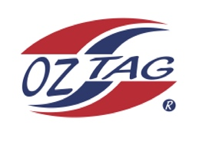
Boys 16 Cronulla State Cup Representative Team 2021

Congratulations to the following players selected in the 2022
Sutherland representative team

1. | Taj Wever
2. | Ryan Wotton
3. | Levi Dowling
4. | Zane Bell
5. | Zane Walker
6. | Sebastian Newman
7. | Rocco Hagan
8. | Max O’Halloran
9. | Kobe Sorenson
10. | Harry Perrau
11. | Kai Boyle
12. | Ashton Lumston
13. | Kobe Lillis
14. | Aiden Hodges
15. | Rex Prosser
16. | Jake Santegelo
 | SHADOWS (IN NO PARTICULAR ORDER)
1. | Cooper Shobrook
2. | Bailey Sims
3.
4.

To accept your position please text/email the coach
By Friday 25th February 2022

Coach. _Luke Wever_& Jason Dorahy__________________________ Mobile. ___0400421657 _________________

Email _weverluke@gmail.com_______________________________________________________

Manager. ___Liz Wever_______________________ Mobile___0413342224____________________

Email ________________________________________________________

Email ____________________________________________________________

