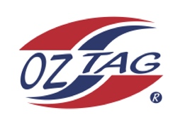
Boys Under 15 Cronulla State Cup Representative Team 2021

Congratulations to the following players selected in the 2022
Sutherland representative team

1. | Jack Schumacher
2. | JettMurphy
3. | Patrick Ryan
4. | Cody Beckett
5. | Tate Nichols
6. | Joel Cornock
7. | Tommy Franks
8. | Elijah Cooper
9. | Harrison Cavanagh
10. | Issac Lopes
11. | Zac McPherson
12. | Liam Bova
13. | Logan Buddle
14. | Dylan Key
15. | Jacob Benton
16. | Jarvis Weaver
 | SHADOWS (IN NO PARTICULAR ORDER)
1.
2.
3.
4.

To accept your position please email the coach
By Friday 25th February 2022

Coach Lee Murphy tatumandlee@hotmail.com
Coach. ____________________________ Mobile. ____________________

Email ________________________________________________________

Manager. __________________________ Mobile_______________________

Email ________________________________________________________

Email ____________________________________________________________

