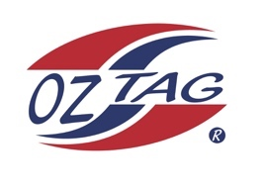
Boys Under 12’s Cronulla
Representative Team 2022

Congratulations to the following players selected in the 2022 Cronulla
representative team

Name
Cruz Wever
Billy Telford
Bailey Silver
Bear Laffan
Lenny Bucher
Kash Lemke
Marshall Barlow
Zane Smith
Jack McKevett
Koa Cooper
Tyler Moon
Roy Eisenhuth
Ethan Mullins
Cooper Brenton

Coach:Paul Laffan. Phone: 0419288851

Manager:Leanne Laffan. Phone: 0409922773

