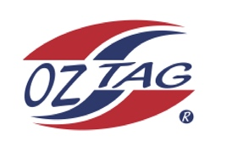
Boys Under 10 Cronulla State Cup Representative Team 2021

Congratulations to the following players selected in the 2022
Sutherland representative team

1. | Knox Anderson
2. | Jackson Best
3. | Taio Dorahy
4. | Taj Forster
5. | Sonny Gilder
6. | Caleb Hoekstra
7. | Koby Hyde
8. | Noah Kelly
9. | Arlo McPherson
10. | Braxton Monaghan
11. | Rory Pierce
12. | Ohio Pure
13. | Chase Spradbrow
14. | Alexander Sheppard
15. | Flynn Tolman
16. | Zach Wilson
 | SHADOWS (IN NO PARTICULAR ORDER)
1. | Sonny Barlow
2. | Cruz Judd
3. | Zac Maguire
4. | Mac Murphy

To accept your position please text/email the coach
By Saturday 26th February 2022

Coach. Cain Best
Mobile. 0418 263742
Email cainbest@cipconstruct.com.au

Coach. Scott Wilson
Mobile 0413 550589
Email scott.wilson@ljharper.com.au

Email ____________________________________________________________

