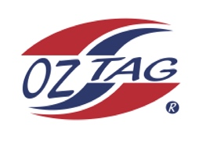
Girls Under 10 Stingray National
Representative Team 2021

Congratulations to the following players selected in the 2021
Stingray representative team

1. | Sophie Aungle
2. | Felicity Barnes
3. | Leah Fowler
4. | Ava Garvan
5. | Sophie Howson
6. | Michaela Jenkins
7. | Isabella Komon
8. | Georgia Laverance
9. | Joscelyn Lemke
10. | Alexia Mathison
11. | Capri McCArthy
12. | Olive Maquire
13. | Allyra Sorensen
14. | Ruby Walker
15. | Lucy Watkins
16. | Ronia Warszawska
 | SHADOWS (IN NO PARTICULAR ORDER)
1. | Piper Brenton
2. | Layla Harma
3. | Mackenzie Franks
4. | Charlie Doyle

Coach: Michael McCarthy Phone: 0424824032 ( Michael)
Email: mickmcc82@hotmail.com
Assisant Coach Zane Walker

Manager: Belinda Laverance Phone: 0452301060
Email:
To accept your position please text/email the coach by Thursday 19th August

NB if the tournament is cancelled due to Covid 19 a full registration fee will be
refunded. Uniforms and extra gear WILL NOT be refunded

