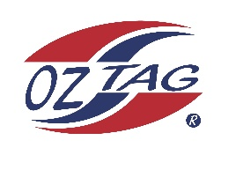
Boys under 15 Stingray National
Representative Team 2021

Congratulations to the following players selected in the 2021
Stingray representative team

1. | Zane Bell
2. | Rocco Hagan
3. | Sebastion Newman
4. | Max Halloran
5. | Rex Prosser
6. | Kobe Sorensen
7. | Taj Wever
8. | Zane Walker
9. | Harry Perrua
10. | Cooper Wooley
11. | Aidan Hodges
12. | Jake Santangelo
13. | Ryan Wotton
14. | Mitch Slater
15. | Levi Dowling
16. | Kai Boyle
 | SHADOWS (IN NO PARTICULAR ORDER)
1. | Bailey Sims
2. | Oliver Luthje
3. | Adrian Krizmanic
4.

Coach: Luke Wever / Jason Dorahy Phone: 0400421657 / 0414272681
Email: weverluke@gmail.com

Manager: Luke Wever Phone: 0400421657
Email: weverluke@gmail.com

To accept your position please text/email the coach by Thursday 19th August

NB if the tournament is cancelled due to Covid 19 a full registration fee will be
refunded. Uniforms and extra gear WILL NOT be refunded

