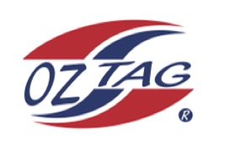
Boys Under 11 Stingray National
Representative Team 2021

Congratulations to the following players selected in the 2021
Stingray representative team

1. | Bailey Silver
2. | Bear Laffan
3. | Cruz Wever
4. | Cooper Shephard
5. | Cash Peek
6. | Cooper Laverance
7. | Cruz Morris
8. | Ethan Mullins
9. | Jack McKevett
10. | Koa Cooper
11. | Kash Lemke
12. | Lenny Bucher
13. | Marshall Barlow
14. | Randy Ennis
15. | Roy Eisenhuth
16. | Zane Smith
 | SHADOWS (IN NO PARTICULAR ORDER)
1. | Tyler Moon
2. | Austin Highett
3. | Kaden Mangioni
4. | Corey Brown

Coach: Paul Laffan Phone: 0419288851

Manager: Leanne Laffan Phone: 0409922773

To accept your position please text the manager by Thursday 19th August

NB if the tournament is cancelled due to Covid 19 a full registration fee will be
refunded. Uniforms and extra gear WILL NOT be refunded

