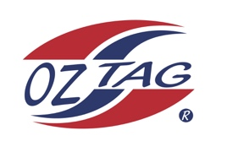
Girls Under 14’s Sutherland
Representative Team 2021

Congratulations to the following players selected in the 2021 Sutherland
representative team

Name
Alexi Eisenberg
Emma Gorman
Chloe Liddell
Keira Lampasona
Candice Laffan
Zoe Gilberd
Charlee Hedley
Hayley Walsh
Ella Hewitt
Maddie Marshall
Leah Moffitt
Lily Chapple
Tully Rayner
Lili Zmisa
Gemma Hanley
Tace Edwards
Shadows
Zoe Cryer
Georgie Lauxmann
Annabelle Grant

Division

Coach:Leanne Laffan Phone: 0409922773

Manager:Louise Liddell Phone: 0417020185

