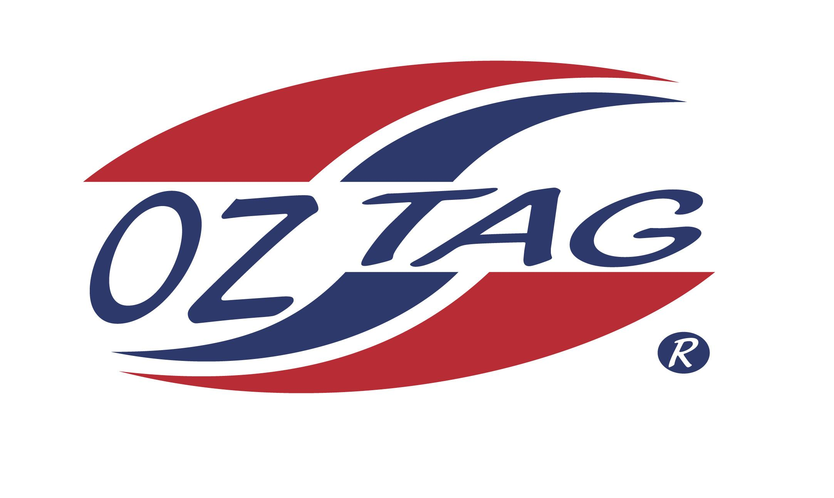
Girls Under 13 Sutherland
Representative Team 2021

Congratulations to the following players selected in the 2021 Sutherland
representative team

Name
Antonnea Arfanis
Nova Batman
Holly Farrell
Martha Gregory
Paige Hagan
Rubie Hedley
Sara Hickey
Abbie Jackson
Zara Loveday
Chloe Ozolins
Keira Parker
Bridget Rommel
Bronte Snoxall
Sienna Wilson
Charlotte Woolnough
Katie Zeng
SHADOWS
- Hannah Silver
- Shanae Holmes

Division 1

Coach: Jason Snoxall Phone:
Email:

Manager: Danielle Ozolins Phone:
Email: deeors@yahoo.com.au

