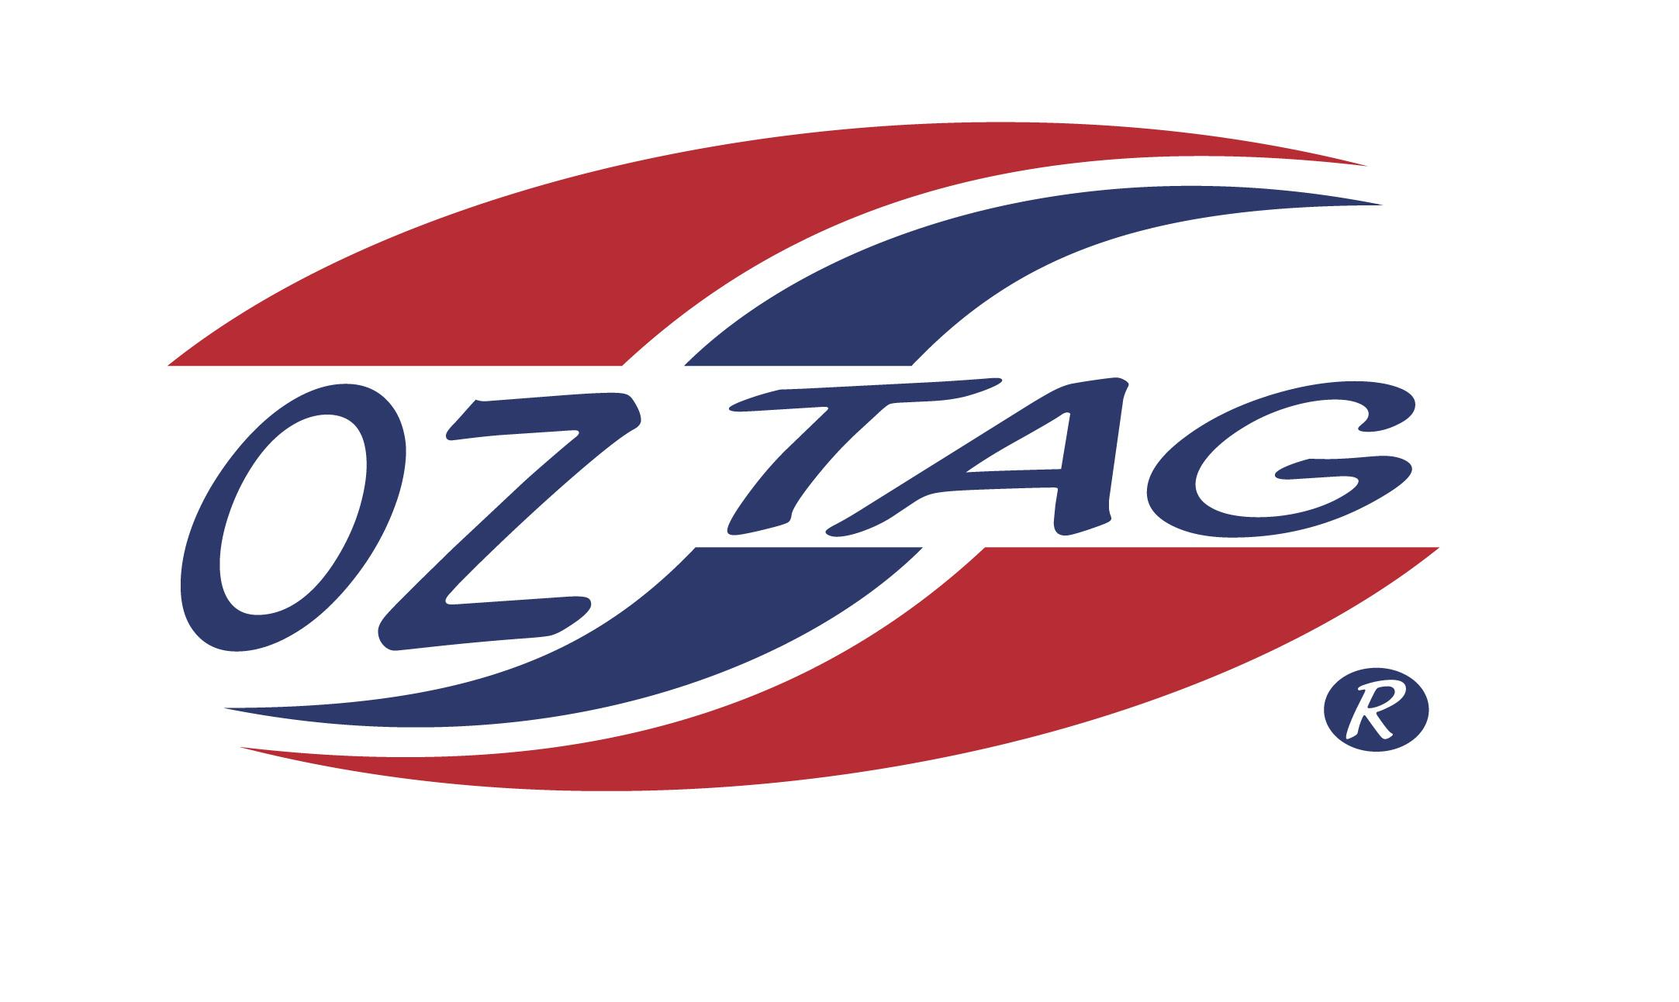
Girls Under 10’s Sutherland
Representative Team 2021

Congratulations to the following players selected in the 2021 Sutherland
representative team

Name
Peyton Shaw
Jocelyn Lemke
Poppy Johnson
Talia Panozzo
Sophie Augnle
Gracie Rapp
Keelie Massone
Olivia Van Dyk
Mikayla Khan
Maya Ellmoos
Piper Brenton
Michaela Jenkins
Rachel Dibden

Division: Sutherland U10’s Girls

Coach: Britney Vella Phone: 0435 113 045
Email: britney.vella1@gmail.com

Manager: Corinne Rapp Phone: 0418 404 645
Email:

