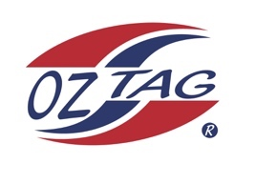
Boys Under 11’s Cronulla
Representative Team 2021

Congratulations to the following players selected in the 2021 Cronulla
representative team

Name
Cruz Wever
Cooper Laverance
Randy Ennis
Bear Laffan
Lenny Bucher
Fletcher Ablett
Dane Wilson
Zane Smith
Jack McKevett
Bailey Silver
Tyler Moon
Roy Eisenhuth
Ethan Mullins
Cooper Brenton
Kash Lemke

Coach:Paul Laffan. Phone: 0419288851

Manager:Leanne Laffan. Phone: 0409922773

