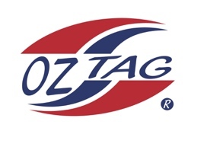
10 Boys Stingray Representative
Team 2020

Congratulations to the following players selected in the 2020 National Stingray team

Name
Bear Laffan
Cooper Laverance
Ethan Mullins
Koa Cooper
Randy Ennis
Cruz Wever
Jack McKevett
Cooper Shephard
Tyler Moon
Bailey Silver
Roy Eisenhuth
Austin Highett
Zane Smith
Marshall Barlow
Lenny Bucher
Kaden Mangioni
Shadows
Cash Peek
Corey Brown
Cruz Morris
Kash Lemke

Division 10 Boys

Coach:Paul Laffan
Phone: 0419288851

Manager:Leanne Laffan
Phone: 0409922773

