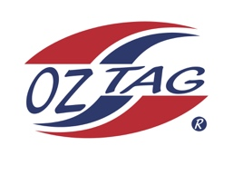
Girls Under 9’s Sutherland Representative
Team 2020

Congratulations to the following players selected in the 2020 State
Team for Sutherland.

Name
1. Piper Brenton
2. Sophie Aungle
3. Payton Kench
4. Chloe McKevett
5. Ashlyn Gorman
6. Jordyn Helm
7. Talia Panozzo
8. Poppy Clark
9. Isla Vilivili
10. Mikaela Khan
11. Keelie Massone
12. Sage Boothroyd
13. Mia Wood
14. Asha Hills
15. Rachel Dibden
16.
SHADOWS:
17.
18.
19.
20.

Division – Girls Under 9’s

Coach: Melanie Brenton
Phone: 0406075991
Email: melanie@mjbwplanthire.com.au

Manager: Lauren McKevett
Phone: 0426503476
Email:

