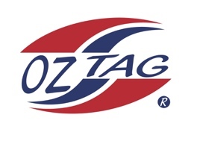
Girls under 13 Sutherland Representative
Team 2020

Congratulations to the following players selected in the 2020 State
Team for Sutherland.

Name
1. Candi Laffan
2. Jasmine Sidoti
3. Madison Marshall
4. Ella Hewitt
5. Chloe (coco) Liddell
6. Leah Moffitt
7. Lili Zmisa
8. Tully Rayner
9. Emma Gorman
10. Gemma Hanley
11. Lily Chapple
12. Hayley Walsh
13. Chiara Ceneigh
14. Zoe Gilbert
15. Alexi Eizenberg
16. Halle Seidel
SHADOWS:
17. Keira Lampasona
18.
19.
20.

Division 13 Girls Sutherland

Coach:Leanne Laffan
Phone: 0409922773

Manager:Louise Liddell Phone:0417020185

